## 

## 4

## Merchant

Demo date: September 30, 2024  
Scoping start date: Sep 30, 2024

MSA Signature Date: Oct 29, 2024  
Onboarding Kick Off Date: Nov 1, 2024

[If Exists] Opt Out Date: N/A  
Go Live Date: Nov 18, 2024

GTM POC: Rebecca  
Implementation POC: Ariel

ERP: QBO

Tax Integration: QBO Hard Coded Taxes

### 

### Key people at Merchant

### 

### CFO & CEO: Ed Hagan ([ed@satisfilabs.com](mailto:ed@satisfilabs.com))

* Finance Lead/VP: Jonathan Scott ([jon@satisfilabs.com](mailto:jon@satisfilabs.com))

### 

### 

| Notes Sections [Ops International Team to Ignore] *(AE/ Implementation to fill)*   * Info on how merchant bills   + Spreadsheets related to implementation * Is there any important merchant relationship information?  1) What is the merchant temperament? 2) Is there a key POC: (i.e.: who is the buyer/decision maker?) 3) What are the Tabs features that the key POC cares about? |
| --- |

### 

### Company summary *(AE to fill)*

Satisfi Labs is provides an AI Chat platform for customer experience teams. Satisfi Labs generates revenue by offering AI-powered conversational search and customer engagement tools tailored for venues, events, and brands. Their platform allows companies to automate customer support, answer FAQs, and enhance the customer experience with real-time information across multiple channels like web, mobile, and messaging apps.

They typically charge clients based on a subscription model, where fees depend on factors like the scale of deployment, volume of queries, and customization needs. Their solutions are popular in industries like sports, entertainment, and retail, where personalized, instant engagement is a priority.

Goals (North star)  
*(AE/ Implementation to fill)*

What is the merchant's goal? What pain are we solving? Why are they buying Tabs?  
Manual billing

Lack of reporting in QBO

Collections / AR issues

Lack of connectivity between SFDC and QBO

Is there an opt out clause? If so, what is the merchant looking for so they do not exercise it?  
No

### Billing model *(AE/ Implementation to fill)*

* Mostly annual billing
* Many SKUs
* Bundles and discounts
* Some usage for overage for new product line they just acquired

### Contract Processing Steps *(Implementation/Success to fill)*

**Things to note for bulk processing:**

* All customers should already exist in QBO. If a customer does not exist, please flag before adding a new one.
* If a new customer needs to be added, be sure to check the currency, as they have many customers with international currency

1. Steps to process
   1. All contracts will have order forms in the format of a table (example below)
   2. Mostly annual up front billing
      1. Some exceptions for quarterly and monthly, will be outlined in the contract
      2. Most contracts are multi-year
      3. **Rev schedules should encompass for each individual year, as opposed to for all years of the contract (this is because there can be product differentiation year over year)**
   3. Process all lines in the table of the order form
      1. Some products are bundled - **for Included items, process as $0**
         1. Despite bundles, all line items in the table should be processed
      2. Use quantities in quantity table
      3. Process both Product Name and Description from the table
      4. Discount processing can vary. One type of discount should be in the item and the other is its own line item.
         1. Discounts - Services: Apply this discount to the BT for Implementation
         2. Discounts: This should be a separate BT
      5. Integration items
         1. ~~If it can easily be found/inferred based on item title, link to that~~
         2. ~~If there is no obvious match, leave blank and the system will either auto-match or leave blank~~
         3. *~~** This is because they want to clean up their integration items, and will use Tabs contract processing as a way to start the clean up process. Leaving blanks will be a signifier that they need to add one Ror make it clearer which one to match to.~~*
         4. [Here is a master list of all of the current items we have processed and what integration item they should map to.](https://docs.google.com/spreadsheets/d/166kAwEeRhlYeQMFkuUsqpw03zSc0tO_KdMRs4yyu9zY/edit?gid=0#gid=0)
      6. Auto-renewal
         1. **ALL Satisfi contracts are allowed to auto-renew, please process 1 extra year for each contr/.act based on the terms of the last year of the order form UNLES**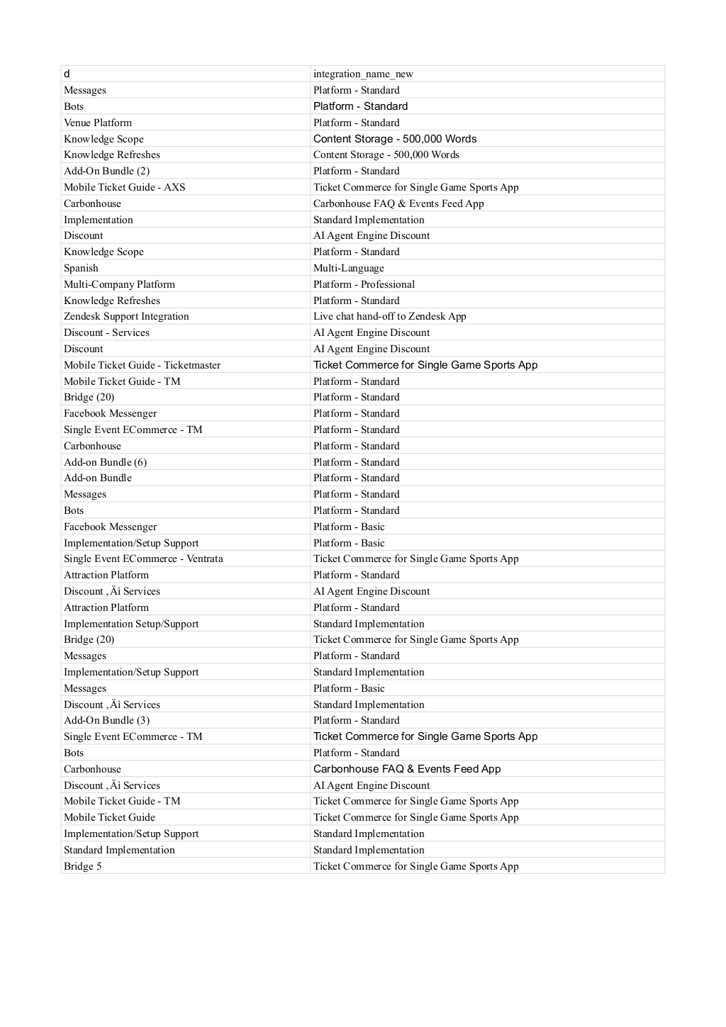
         2. **S it is explicitly stated in the contract that it is NOT to auto-renew. This should be a new set of BTs for this extra year.**

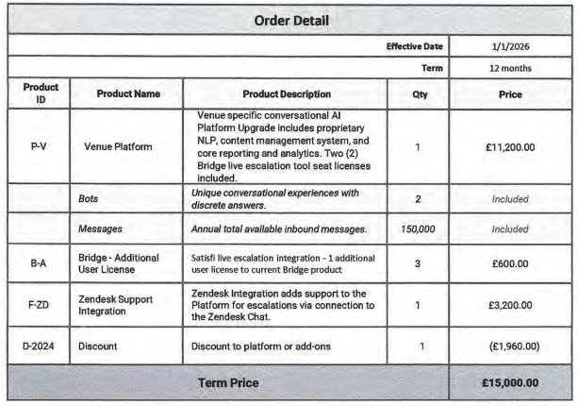

**Usage**

* They have 5 contracts that charge usage today. This will be expanding, and as their usage model grows, this section will be updated.
* For the 5 that exist today, they are pay as you go with standard use for 2 different products:
  + WhatsApp
  + SMS
* This will be formatted in a table that looks like the below example
* Instructions:
  + In the ADD-ON Packages section, it will say YES next to WhatsApp or SMS if those usage items apply
  + If so, their rates will be in the next table below
  + BT processing:
    - Name: WhatsApp Messaging / Mass SMS (from the first table)
    - Integration Item
      * Channel:WhatsApp
      * Channel:SMS
    - Event type:
      * SMS
      * WhatsApp
    - Start Date: 1st of the month of contract sign date. If the contract is not signed on the 1st, and an extra month to the total amount of months bills to account for the last month
    - In Arrears
    - Monthly, unless specified otherwise in the contract

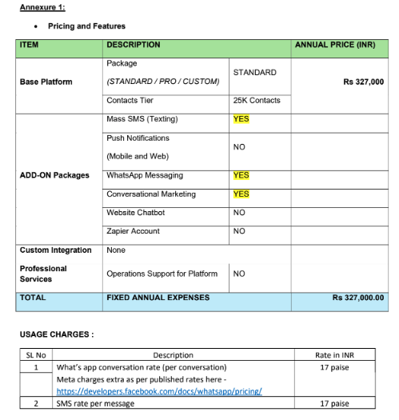

1. Anything to ignore in contracts?
   1. No
2. Specifics processing things the merchant has requested that may differ by contract (e.g. always back-date invoice date to final day of the month)
   1. No
3. Default Service Term
   1. If None Listed, Ops Default is 1 Year
4. Default Net Payment Terms
   1. If None, Ops Default is 30
5. Default Billing Frequency
   1. If None Listed, Ops Default is Annual
6. How do we handle taxes as a line item?
   1. If None Listed, Ops Default is every tax line item becomes a BT

### Events Processing (if necessary) *(Implementation/Success to fill)*

* Will be starting to bill usage overages with a new product line called “marketing engine”
  + Still implementing, Ops to ignore for now

Integration Items Processing (if necessary)  
*(Implementation/Success to fill)*

* Map to obvious mapping
* If not obvious, leave blank

Post Processing Communications (if necessary)  
*(Implementation/Success to fill)*

Class field (Ops to ignore)

* Use for customer segments
* All BTs in a contract would be assigned the same class fields
* Implementation plan
  + We are going to import the class field for all processed contracts
* Net new
  + Come up with a plan with product/ops to account for this going forward

### Customer Information *(Implementation/Success to fill)*

* Any important information on specifics customers of this merchant
  + No

### Feature Requests *(AE/Implementation/Success to fill)*

* FR 1
  + What is it
  + Why it's important
  + Urgency

### Rewatch Calls *(AE/Implementation/Success to fill)*

* May 2 <https://tabs.rewatch.com/video/bnsnuyi1m9m2alup-ed-and-rebecca-schwartz-tabs-may-23-2024>
* June 5 <https://tabs.rewatch.com/video/aom1sb5hx2srifs5-ed-and-rebecca-schwartz-tabs-june-5-2024>
* June 7 <https://tabs.rewatch.com/video/4kmidjc4ktdcwffx-ed-rebecca-tabs-june-7-2024>
* September 30 <https://tabs.rewatch.com/video/kvz9frd0s4j99h8m-satisfi-labs-tabs-september-30-2024>